**CBF analysis Graphical User Interface (GUI) guide**

This document provides instructions on installation and usage of GUI for CBF analysis GUIcalculator, implemented in Matlab 2020b (Natick, MA). The user will need ideally most recent version Matlab and have Image Processing, Signal Processing and Parallel Computing toolboxes installed. Older version of Matlab that do not support Maltab App Designer will not be usable as this GUI was designed using App Designer and GUIDE interface in Matlab. Please ensure to download the full package including the gui file CBFcalculator.mlapp, CBFcalculator.prj and supporting scripts computeCPFperPixel.m, readOMEAlternative.m, smoothSeries.m, GetOMEData.m as well as Open Microscopy Environment (OME) package for matlab inside zipped folder ‘bfmatlab’. Please ensure all of these are in a common folder within the home Matlab directory installed on the computer used for analysis.

First proceed by packaging the GUI by opening the CBFcalculator.prj file in Matlab session as shown in Figure 1:

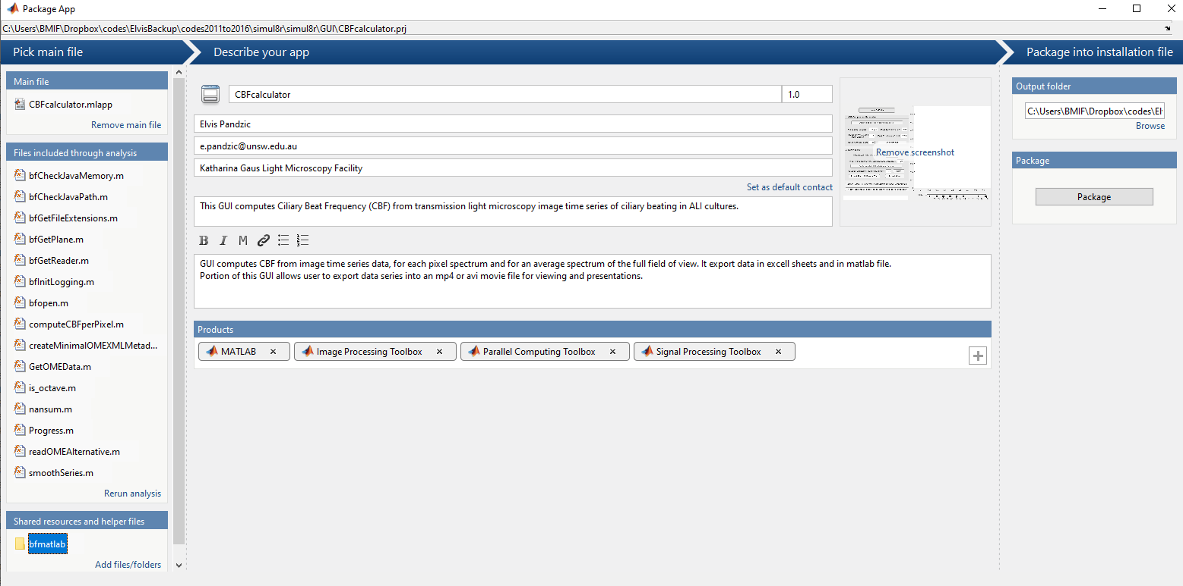

4

3

2

1

**Figure 1: packaging GUI in Matlab using CBFcalculator.prj file.**

Click on ‘Remove main file’ as shown in ‘1’ above and then click on ‘Add main file’ and select CBFcalculator.mlapp file in the folder you have saved on your local Matlab folder. Then click on ‘Add/files/folder’ as shown in ‘2’ above and select the unzipped ‘bfmatlab’ folder on your local folder where you saved all the scripts. Next, ensure all the toolboxes are added as shown in the Figure 1 at ‘3’ and use ‘+’ to add them. Please ensure those toolboxes are added to MAtlab during the installation process, as ‘+’ does not install them, only adds them to this GUI. Lastly, click on ‘Package’ as shown in ‘4’ above. The packaging will proceed and when finished it will display at position 4 of Figure 1, ‘Packaging Complete’ (Figure 2a). In the folder where .mlapp and .prj file for this GUI were placed, you will notice a new file CBFcalcualtor.mlappinstall. Please click on this file and it will open the window as shown in Figure 2b. Click on ‘Install’ and this proceed to add the packaged GUI to 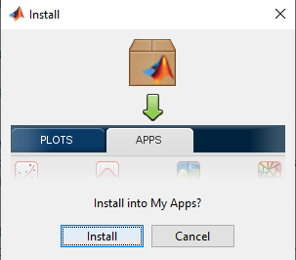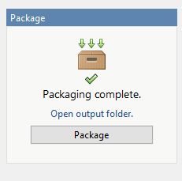the ‘Apps’ tab of Matlab.

**B**

**A**

**Figure 2: Packaging and Installation of GUI for CBF analysis.**

Now that GUI is installed, please navigate to Matlab’s ‘Apps’ tab at the top and click on the arrow indicated by ‘1’ below to see all the available Apps, both Matlab built in and custom made ones. In the section ‘My Apps’ you will only have CBF calculator app installed as shown in ‘2’ in Figure 3 below.

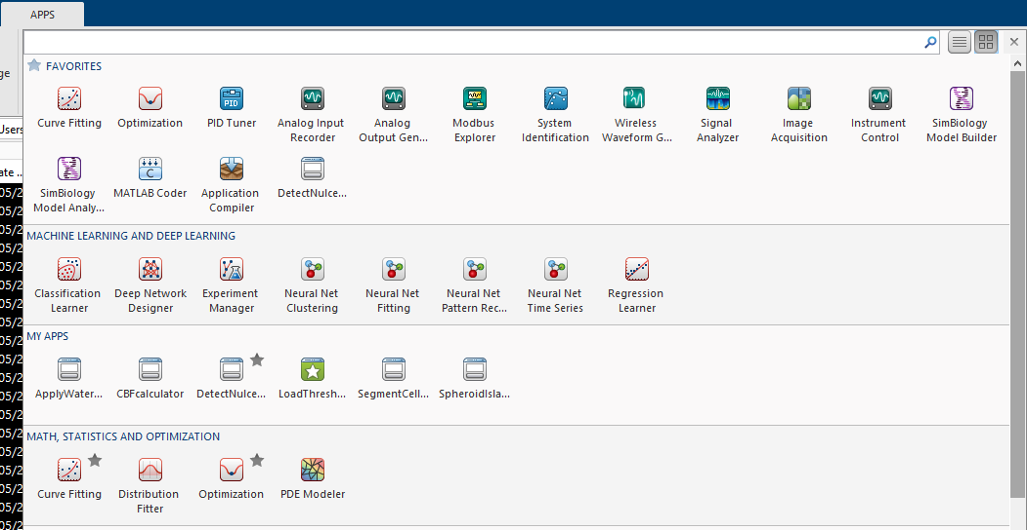

2

1

**Figure 3: Where to find the installed GUI.**

Click on the CBF calculator GUI to open the GUI as shown in figure 4 below. Click on the button ‘1’ as shown in Figure 4. You will be prompted to select one OME file, in this case a Nikon data file like nd2 or similar. The data image series will load and display in axes labelled by ‘20’. Use the slider labelled in ‘19’ to explore your image series. Button labelled by ‘2’ applies temporal immobile filtering as shown later in figure 5. Buttons ‘3’ and ‘4’ read in the time frame (seconds) and pixel size (micrometers) from the data file metadata, so ensure it is correct and change if needed. Parameters ‘5’ and ‘6’ define the minimum signal-to-noise and peak prominence of the CBF spectra peaks finding algorithm (see supplementary document for details). Parameter ‘7’ is size of clusters applied to the mask that exclude all the noise area, not containing any cilia, in the field of view, in the computation of the average spectra and CBF. Button ‘8’ initiates computation of CBF. ‘9’ allows to select what format should a video of data be saved in. ‘10’ defines the video frame rate. Button ‘11’ when pressed ensures temporal immobile filtering of data. ‘12’ defines sigma of 2D Gaussian denoising filter. ‘13’ applies 2D Gaussian denoising filter on each image using sigma defined in ‘12’. Button ‘14’ allows user to ouput only first 100 frames, which is faster than whole larger data set, and preview of output allows the user to decide whether to change parameters 9-13. Button ‘15’ exports movie of full data set using parameters defined in 9-13. *Note: Please user the slider ‘19’ to preview the filtered data after either of buttons ‘11’ or ’13’ is pressed before proceeding to press buttons ‘14’ or ‘15’ to output movie. This ensures that axes ‘20’ are displaying the filtered data prior to exporting the movie*. Buttons ‘16’ and ‘17’ allow batch CBF analysis and movie exporting. Please see Batch processing section below for further details.

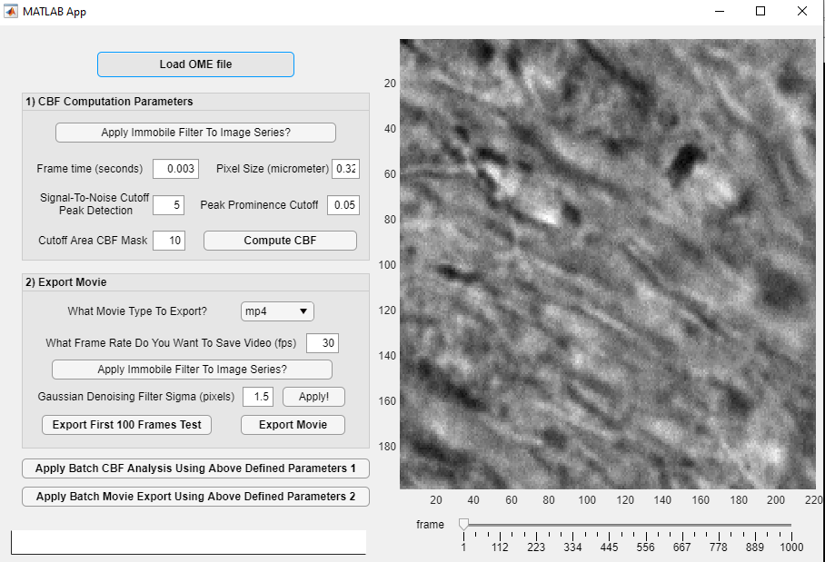

12

11

10

20

19

18

17

16

15

14

13

9

8

7

6

5

4

3

2

1

**Figure 4: Overview of CBF calculator GUI and data import.**

When all the parameters 2-7 have been defined, press button ‘8’ yo proceed with the analysis. The progress bar labelled in ‘18’ will show how far the analysis is as shown in Figure 5:

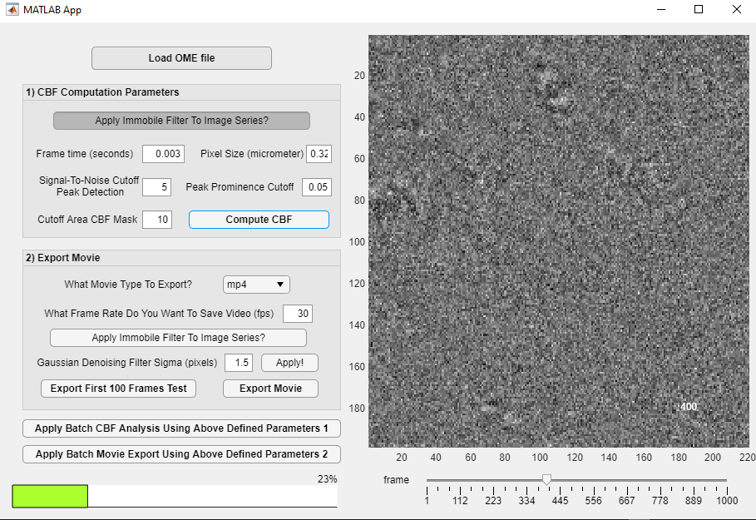

**Figure 5: CBF analysis in progress.**

Once the analysis is finished You will see the display of the average spectrum and peaks detected in the axes as shown in Figure 6 below.

**Figure 6: CBF analysis is finished and average spectrum displayed.**

In the data folder you will notice that two excel files were generated, one containing CBF peaks amplitudes and frequencies, for each pixel, and other the average spectrum and its CBF summary. Also, you will have the image of average spectrum and peaks detected outputted. Finally there will be a Matlab data file (.mat) outputted containing all the outputs, which can be loaded into Matlab workspace for further data examination. When exporting movie, please ensure you have adjusted parameters 9-13 as shown in Figure 4 and use button 14 to output a subset of first 100 frames, to see if movie frame rate and filtering setting is what is desired before proceeding with using button 15, for outputting final movie as shown in Figure 7 below:

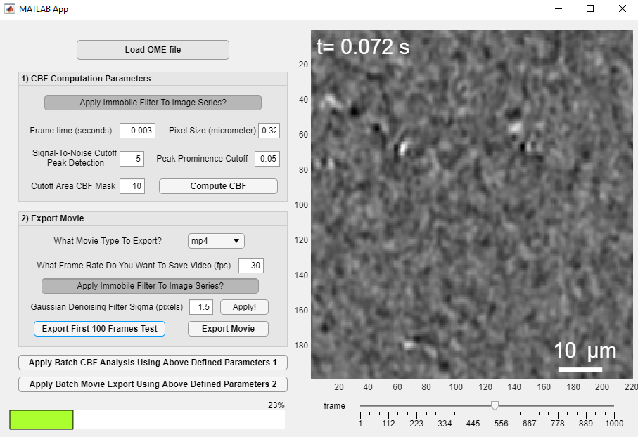

**Figure 7: Outputting a movie of first 100 frames of a data into an mpf4 file.**

**Batch Processing**

Before Using batch processing of several files, with button ‘16’, please ensure that all the parameters 2-7 are defined on a file and tested before hand.

Similarly, when wanting to only export movies for several data files using button ‘17’, ensure to load (button 1) 1 data file and explore parameters 9-13 before attempting doing batch export of movies. Ensure to refresh axes ’20’ after filtering buttons (2, 11 or 13) have been pressed, to visualise that filtering steps have occurred before pressing any of the data processing/movie output buttons (8, 14-17).